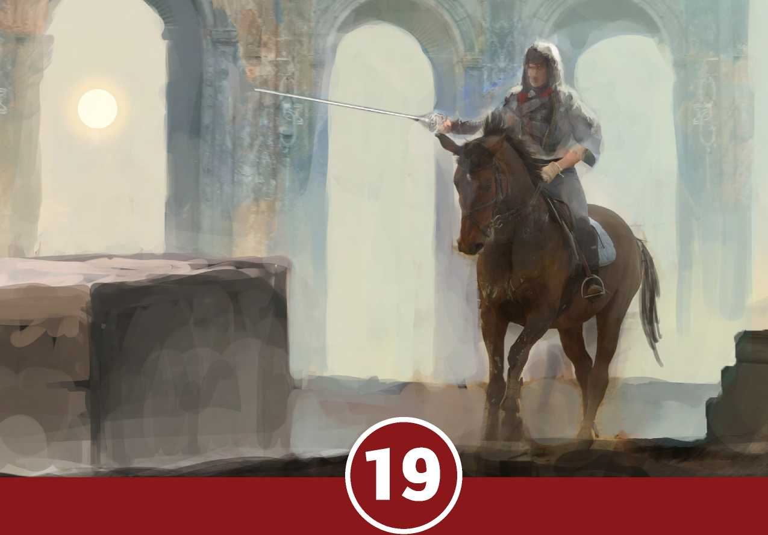

issue nineteen

july 2020

COHORTS and dynasties

* New rules for dynasties, including birth, succession, blood rights, and more.
* New mechanics for adventurer-scale battles with large formations of troops

A dventurer Conqueror King

**SYSTEM™**

**AXIOMS™ ISSUE NINETEEN**

*Axioms Issue 19* ©2021 Autarch™ LLC. Adventurer Conqueror King System © 2011-2021 Autarch LLC. The Auran Empire™ and all proper names, dialogue, plots, storylines, locations, and characters relating thereto are copyright 2011-2018 by Alexander Macris and used by Autarch LLC under license. Some interior art is copyright William McAusland and used with permission. Cover art is copyright vukkostic and used with permission. All other material is protected under the copyright laws of the United States of America. Any reproduction or unauthorized use of the material or artwork contained herein is prohibited without the written permission of the copyright owners. Autarch™, Adventurer Conqueror King™, Adventurer Conqueror King System™, ***ACKS***™, Axioms™, and Domains of War™ are trademarks of Autarch™ LLC. This product is a work of fiction. Any similarity to actual people, organizations, places, or events is purely coincidental.



CREDITS

**Publisher & Editor-in-Chief:** Alexander Macris

**Art Director:** Todd Crapper

**Cover Artist:** vukkostic

**Interior Artists:** William McAusland, Michael Syrigos



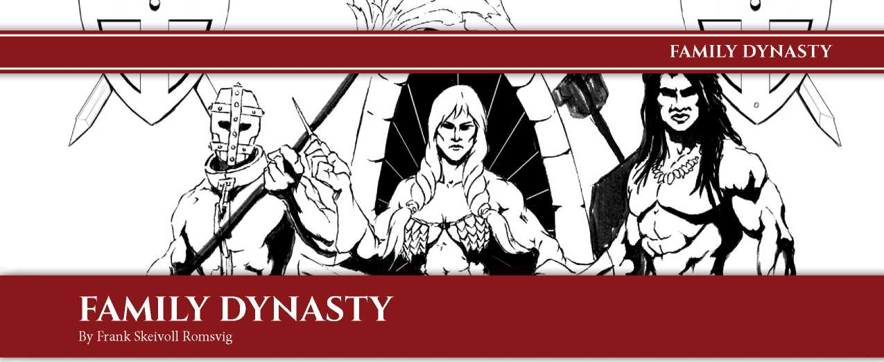

**NATURE OF A DYNASTY**

A dynasty is a set of characters considered as members of the same family. As the game evolves into generational play, the play evolves and will focus around the survival and growth of the player’s dynasty - rather than the actual character. The survival of the dynasty will become more important than the character. In such a game, the current character of the player will generally go on an adventure just a few times a year, typically in the summer when it is easier to travel.

GENERATING YOUR DYNASTY

Follow the steps in the character generation section. Create 5 characters by rolling 3d6 in order of ability score. One set is selected as your main character to be played, while the others are family members. Roll 1d6 and determine the status of your family. You always have a mother and father, but only a roll of ‘6’ below are both alive.

Roll d6 Family Alive

1. Mother, aunt, kinsman and friend
2. Sister, father, uncle and friend.
3. Brother, mother, aunt and kinsman
4. Brother, sister, mother and uncle.
5. Brother, sister, father, aunt.
6. Brother, sister, father and mother.

To keep track of your dynasty members, you fill out the family tree (see the end of this article). First, write the name of your main character, his class name and title, and his noble title (if any).

Then write up the other family members, noting title, first name (or last name if other than family name), class and level in parentheses, date or year of birth, and lastly date or year of death if person is dead.

If a family member marries, the husband or wife’s entry is written with name, class name, and title in the field slightly behind the one where you have written up information regarding your true blood family. See sample below.

Player characters should be marked with a # on the family tree. Heirs should be marked with a crown or heart ©. Bastard children should be marked with a circle •

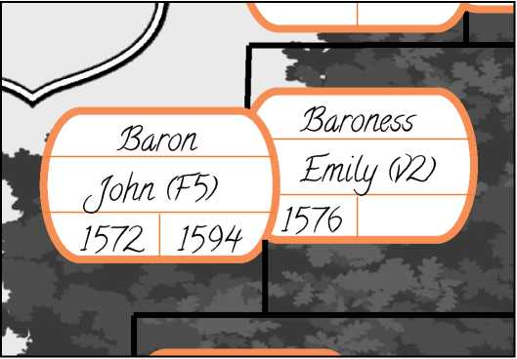

death and succession

The Judge controls all members of your dynasty except for your player character. When you die, you are handed the character sheet of whichever character is your heir - and he becomes your new player character.

Which character will inherit your title and holdings depends on the succession laws governing your dynasty. Unless otherwise determined by the Judge, your dynasty begins with gavelkind succession laws. Even if the succession law requires that your deceased characters estate be shared between several NPCs, you still only play the heir determined by your succession.

If you don’t like the heir you’ll get upon death, you can try to change succession laws to allow you to play the one of your heir that you want. Such efforts are how intrigues are born, as the other members of your dynasty may start to take actions to prevent this - remember, they’re under the Judge’s control!

You can start your heir at a higher level by establishing a reserve fund of experience points that will be available to your new PC when your original character is permanently killed. The number

of experience points in the reserve is equal to the gold piece value of money you allocate to the reserve. The reserve represents your character investing money into the education of his daughter or son. If you want to educate multiple heirs, you must set up multiple reserve funds.

If you have no heirs, the game ends and you generate a new character and creates a new dynasty.

**NoBLEs vs. LowBoRN**

Characters without a dynasty are referred to as lowborn. Technically, Lowborn is itself a “dynasty”, however it lacks any coat of arms or surname. A lowborn character who receives a title is raised to the nobility, becoming the founder of a new dynasty whose name and coat of arms will be chosen and created by the character. His family - or what is left of it - will come forth to start the dynasty.

Children of a legal marriage, or born from a concubine, are of their father’s dynasty. However, in a matrilineal marriage (based upon descent through the female line), the children are of their mother’s dynasty, as are unacknowledged Bastard children.

Unacknowledged bastards will have a custom dynasty name, most of the time created following the [Name of the Property where they’re born]. A noble’s children are never lowborn, so if a noble woman marries a lowborn man, the marriage must be matrilineal (and vice versa).

**BREEDING**

Breeding is required for your dynasty to grow in numbers. Absent powerful magic, breeding requires a male and a female participant. Breeding can occur in the context of a marriage, a concubinage, a harem, or simply due to carousing. By default, humans tend to accept racial mixing with any race except with beastmen. The other races, with some open-minded exceptions, tend not to be as progressive on such matters. (The Judge can alter this for their campaign to their taste, of course.)

**PREGNANCY**

A couple’s racial fertility decides the ability and likelihood of conception. If your character is male, roll 1d20 for each female partner he has during a year while in his fertile age range, up to 8d20 (assign each die to a partner). One check should be done once per active year. On a success, the pregnancy is 1d6 months on its way when discovered. If your character is female, you may roll 1d20 for each male partner she has during a year, up to 3d20. Please note that if a character becomes pregnant and the other partner is not their spouse, the resulting child is a bastard.

|  |  |  |  |  |
| --- | --- | --- | --- | --- |
| R**ace** | 1**d**20 | C**hild age** | Y**outh age** | F**ertile age** |
| Human | 1-9 | 1-14 | 15-17 | 18-35 |
| Dwarf | 1-5 | 1-14 | 15-25 | 26-50 |
| Gnome | 1-2 | 1-14 | 15-25 | 26-62 |
| Halfling | 1-6 | 1-17 | 18-20 | 21-42 |
| Elf | 1 | 1-30 | 30-50 | 51-200 |
| Beastmen | 1-12 | 1-11 | 12-15 | 16-30 |

EXAMPLE: A male human noble has an elf wife and two human lovers. Once per year, he must roll 1d20 for each. He rolls a ‘5’ for his wife, an ‘18’ for his first lover, and a ‘2’ for his second lover. , rolls 1d20 for each of his human lovers and get ‘18’ and ‘2’. The second of his human lovers gets pregnant with a bastard child. The Judge rolls 1d6 and scores a ‘3’; when the pregnancy is discovered, the mother is three months

>•

Humans and beastmen can have up to twelve pregnancies during their lifetime. Dwarves, Gnomes and Halflings can have up to four. Elves can only have two; however, elves have visions of their child to come in advance, so anytime they give birth they may roll up two characters and select the one they favor the most.

**BIRTH**

Unless magic is used to get information sooner, a child’s characteristics are decided at birth, 9 months after conception.

» A child’s sex is simple chance. Roll 1d20: On a 2-10 the child is female; on an 11-19, its male. On a 1, twins are born (roll again for each child). On 20, the child is marked in a special way determined by the judge (roll again for the child’s sex). Triplets, quadruplets, and special twins can result from multiple rolls of 1s and 20s.

» Roll 3d6 in order to generate the ability scores for the child. If the child is marked in a special way at birth, one random ability score may be determined with a 4d6 roll, where the three best numbers or the three worst numbers are selected depending if it is a bad or good omen (random). Take into consideration bloodline traits (q.v.).

» Elves will roll up two different children for each one they get and select the one they favor the most.

BECoMING oF AGE

Human children can begin to make their own decisions when they reach 15 years (youth). This age is most relevant for wealthy dynasties that can pay for education and have seats of power ready or in need of a capable decision-maker. Otherwise, humans become adults at 18 years. Halflings become adults three years later than humans.

Dwarfs and Gnomes generally consider someone adult when they reach their 26th birthday. However, they must take start to responsibility for their own actions when they reach 15 years

(youth). Often a dwarf or gnome may in many ways be more adult than a human at the age of 15, although he may not have clan responsibilities before he is 26 years.

Elves are very different. They evolve more slowly than humans, and are in fact small children until they are aged 15 years; they need at least 30 years before they become young adults at the earliest. A 30-year-old elf looks (and might act) like a 15-year-old human. Not before they are 50 years old can elves be considered adults and can be given proper responsibilities.

Beastmen live a short and fast life, with a brutal end.

BLooDLiNE TRAiTs

If the heir and later inheritor of a dynasty over at least three generations each has the same ability score as its highest, the dynasty will get that stat as their bloodline trait. A dynasty can only have one stat as their bloodline trait.

The benefit of a bloodline trait is that all children in that dynasty get to roll 4d6 for that ability score, selecting the three best dice to calculate their score. If both parents come from dynasties with bloodline traits, the following rules applies. If both dynasties have the same bloodline trait, the children of those parents can roll 5d6 for the trait and select the best three dice. If the dynasties have two different bloodline traits, the child benefit from both.

Elves in particular are concerned with bloodline traits and the purity of the elven bloodline. After all, a half-elf gains no elven traits and often doesn’t even gain the long life of the elf. Elven dynasties feel only sorrow if an elven female gives birth to a half- elven child. Almost all elves belongs to old dynasties and have bloodline traits. A judge may allow players that create their first character to decide that they are playing an elf before they roll their character. This will allow them to gain the benefit. (The Judge can make elves more progressive in their campaign, of course.)

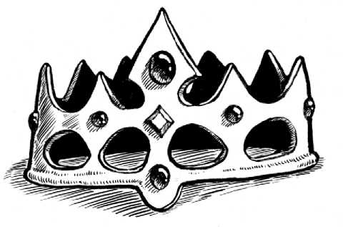

EDucATioN AND cLAss

Commoners, lowborn, and dynasties without the wealth required to buy an education for their children, must use the widespread arrangement with master and apprentice. Talented children with high ability scores will have no difficulties finding a good master. For the other children, their only hope is that their father or mother (or other family member) will become their master and they must learn from him or get no education at all. A player character parent or family member may take a child along on adventure, but this will take one of his henchmen slots. It is also highly dangerous!

Highborn and wealthy dynasties can just pay for the education. The parents set up a reserve fund where one gold piece equals one experience point. The child can become any class desired. It takes one year, regardless of class, to reach level one. It takes two additional years to become level two, and additional two years to become level three, and so forth.

succEssioN LAws

Having a large dynasty gives the player choices for succession.

Under *elective-type* succession laws, the heir is selected.

» With *feudal elective*, one elected inherits all titles.

» With *gavelkind elective*, one elected dynastic member gains the main title.

» With *tanistry*, one elected dynastic member inherits all titles.

» With *patrician elective*, a council elects one of its own as their leader (doge).

Under *inheritance-type* succession laws, the succession follows birth right.

» With *gavelkind*, the titles are divided amongst the heirs.

» With *ultimo-geniture*, the youngest son or daughter inherits all titles.

» With *primo-geniture*, the eldest son or daughter inherits all titles.

» With *seniority*, the eldest member of dynasty inherits all titles.

» With *patrician seniority*, the eldest member of the council is the leader (doge).

» With *open*, the most powerful descendant inherits all titles.

sTARTiNG succEssioN LAws

Theocracies, syndicates, and senatorial realms does not have succession laws in the ordinary sense of the word. In theocracies only clerics can participate, while in senatorial realms the leaders are often elected by the people. In neither cases is there a need for dynasties, *per se*. However, the members of such organizations consists of people. People that comes from families - that may become dynasties.

Realm Type Starting succession law (d6)

|  |  |
| --- | --- |
| Beastmen or tribal | **1-4:** Tanistry  **5-6:** Open |
|  | **1:** Tanistry |
| Human standard | **2-4:** Feudal elective  **5:** Gavelkind elective  **6:** Gavelkind |
| Dwarven vault | **1-3:** Seniority  **4-6:** Patrician seniority |
| Elven fastness | **1-6:** Seniority |
| Senatorial | **1-3:** Patrician elective  **4-6:** Patrician seniority |
| Syndicate | **1-4:** Open  **5-6:** Feudal elective |
|  | **1-2:** Feudal elective |
| Religious organization | **3:** Open  **4-6:** Patrician elective |

**Changing Succession Laws:** The leader may change the succession laws. The change takes 2d4 months before it takes effect and becomes the law. Until then, the old law is in effect. In senatorial realms, the senate must approve changes to succession law.

**Feudal Elective:** All titles will pass to the elective heir. You can nominate the heir with best statistics. You are not limited to your own children. You can pick any claimant, or any dynasty member you make an elector. Each elector (vassal) gets a single vote, regardless of how many electoral titles they hold. The current ruler always gets a vote, and also breaks ties. Vassals gain a +2 bonus to loyalty under this system, making the realm more stable. This method is also used in syndicate and churches, where all the members get a vote and can become a claimant.

**Gavelkind Elective:** The primary title passes to an elected heir from your dynasty; other eligible sons or daughters will receive parts of the demesne. This divides your realms and title amongst your heirs. Each elector (usually your vassals) gets a single vote, regardless of how many electoral titles they hold. The current ruler always gets a vote, and also breaks ties. Vassals get a +1 bonus to loyalty under this system.

**Tanistry:** All titles will pass to the elective heir. You are not limited to your own children, as you can endorse any dynasty member, but cannot nominate claimants outside your dynasty. In case of a tie, your vote is decisive. There are usually more electors in tanistry than in feudal elective. Common amongst nomads and barbarian tribes. Vassals get a +1 bonus to loyalty under this system.

**Gavelkind:** Going down the succession line, any son or daughter (if the succession law allows it) will have claims on all titles inherited by those that came before him or her, and only on the top-tier titles inherited by those after him or her. Gavelkind creates the perfect conditions for succession crises. The primary heir can lose a large portion of their demesne and may even be reduced to a single county. Meanwhile, the new ruler’s siblings have inherited both claims and land, allowing them to create factions demanding their own installation.

**Primo-geniture:** Primogeniture is a succession law where the eldest child in the dynasty inherits all titles, based on gender laws. Either eldest child, eldest daughter, or eldest son (default) is chosen.

**Ultimo-geniture:** This is a succession law where the youngest child in the dynasty inherits all titles, based on gender laws. Either youngest child, youngest daughter or youngest son (default) is chosen.

**Seniority:** Seniority is a succession law where the eldest member of the dynasty inherits all titles, based on gender laws. Either eldest member (regardless of gender), eldest female or eldest male member of your dynasty is chosen.

**Patrician Elective Or Seniority:** A Patrician (aristocrat) is a member the hereditary ruling class in the medieval free cities. It could be a member of a small elite in any society, like merchants or mages. The patricians would form a council. This council will consists of one person from each family (regardless of gender), males only (default) or only females. In patrician elective; each family will present its candidate and this council would select one of the candidates to be their leader, their Doge. In patrician seniority; the oldest member of the families or the oldest member of the council, will be their leader.

**Open:** The most powerful descendant inherits all. Open succession is often combined with polygamy and typically produces an unusually large number of claimants compared to conventional feudal realms. The one that secure his claim inherits everything, usually after killing all other claimants.

**cAMpAiGN TAsK DELEGATioN**

Some players enjoy micro management, while other players hate it. One of the greatest benefits of establishing a dynasty is that you may decide on how involved you want to be in campaign play. As your holdings, wealth and power grows, it is impossible for you to manage everything. This is also an important lesson in real life. If you want to create something of importance and great renown, at some point you have to trust other people. The player must choose amongst the following. Each will affect the game directly and the player must choose one of them.

HANDs oN (YoU ALoNE).

The ruler is the head of the family and runs everything. No decisions can be made by others. Only the ruler can make decisions and he must be involved with everything. To simulate this, the player himself must keep track of everything: The bookkeeping of campaign record sheets, making lists, and keeping the order of everything he does related to the campaign part. In addition, the character can either do campaign related activities or he can go out on adventures. When he is out on adventure (no longer than a month), no campaign related activities will be executed (and vice versa). The ruler has only servants in his staff.

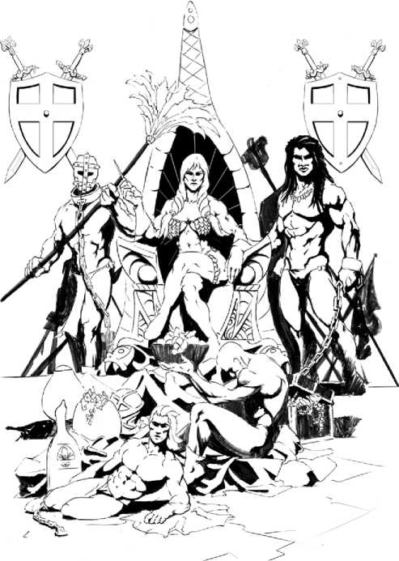

oVERsEER (cHAMBERLAiN).

The ruler only makes important decisions. He is kept updated once or twice a month and in particular when his staff feels he needs to be informed of something important. The Judge keeps track of the player’s campaign records sheets, makes lists, and does the bookkeeping, but the player has access to them. The character may be out on adventures in the summer and either the spring or fall, and the campaign activities will still be taken care of as long as he returns for winter and either spring or fall. A chamberlain is selected from the ruler’s family and operates, with limited rights, in the ruler’s interest at no cost.

DELEGATioN (sTEWARD).

The ruler has delegated authority to a trusted steward. The judge keeps track of his campaign records sheets, makes lists and does the bookkeeping, and the player never sees them. The character may be out on adventure any and all the time. A steward is selected from the family and operates, will full rights, in the ruler’s place at no cost.

BENEFiTs oF A DYNAsTY

The following benefits comes with having a dynasty.

» With wealth and bloodlines your heirs (and future player characters) will receive better ability scores and start with a good education (e.g. they can start at higher level) and will be well equipped.

» You dynasty will supply you with other family members that can be you loyal henchmen (also benefiting from bloodline traits).

» It allows for generational play, where your dynasty will put a mark on the world not only for a short summer, but for decades and several generations. Other races can compete well with the longevity of elves.

» It justifies delegation of campaign tasks (to the Judge).

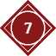

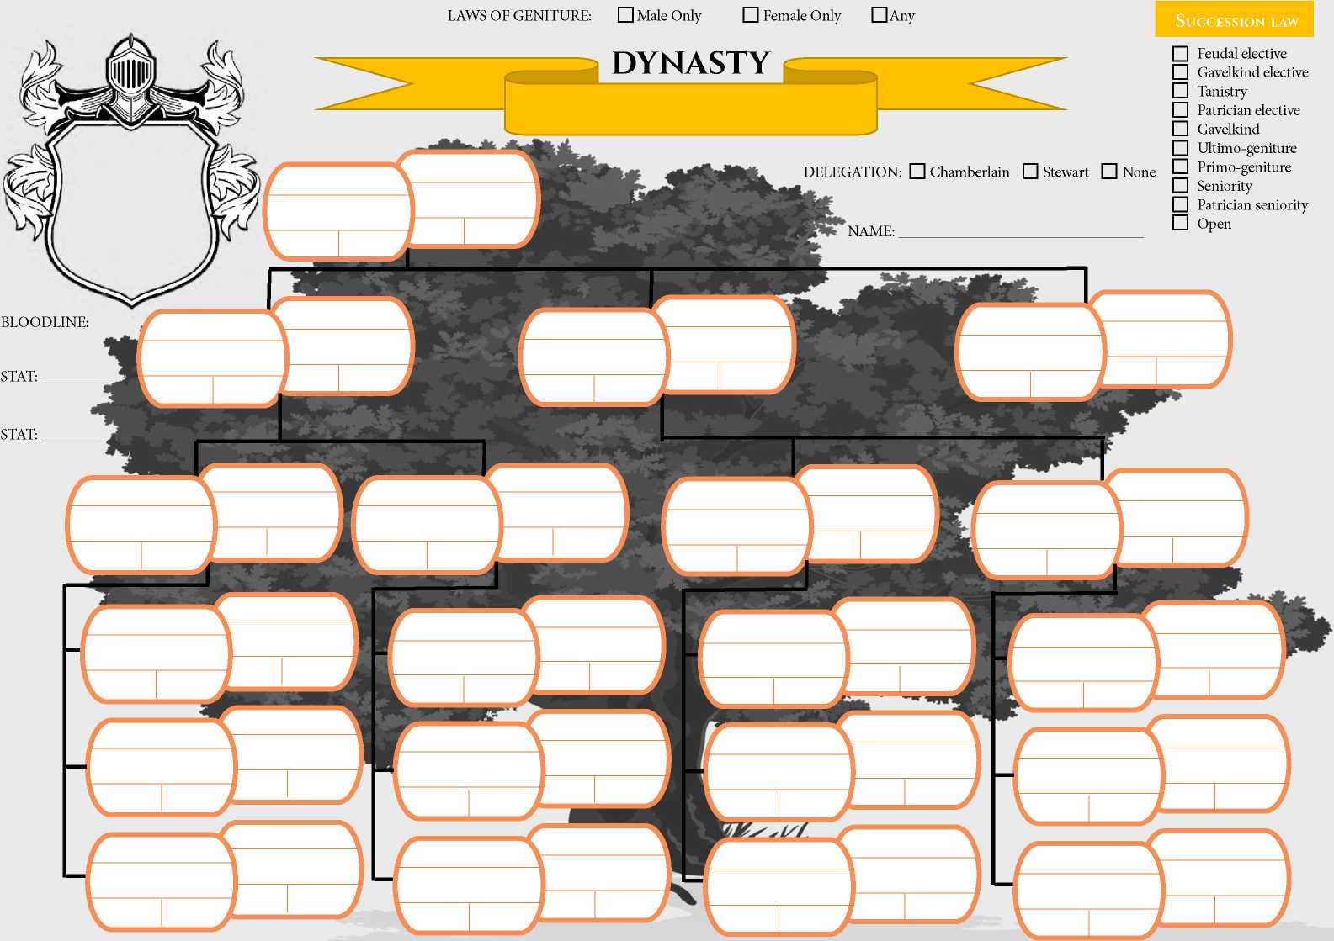

battle formations

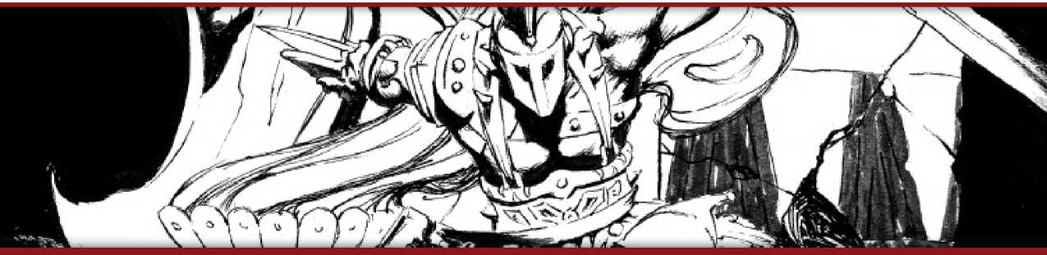

battle formations

By Frank Skeivoll Romsvig

| C**ohort** C**haracteristics** | D**erivation from** I**ndividual** C**haracteristics** |
| --- | --- |
| Cohort Movement (hexes) | Determined by movement of slowest constituent. |
| Cohort AC | Weighted average AC of constituent creatures |
| Cohort Hit Dice | Sum Hit Dice of constituent creatures |
| Cohort Hit Points | Result of rolled Hit Dice. |
| Cohort Types of Attacks | Same as constituent creatures |
| Cohort Number of Attacks | Based on the formation type (each time a creature dies, it may affect the number of attacks) |
| Cohort Attack Throw | Weighted average attack throw of constituent creatures |
| Cohort Damage Rolls | As constituent creatures attacking |
| Cohort Morale | Weighted average morale of constituent creatures, add the modifier of the leader. |

The concept of strategy and tactics in military campaigns had evolved throughout history. Romans are perhaps the best and most prominent example. The variations are many and quite complex. At its core are the concepts of training, equipment, leadership and deployment. The goal is to make several weak individuals stronger - to become stronger as a unified force. War gaming is a style of gaming, where two or more forces - armies - fight each other. The idea in this article is to introduce a simple way to include battle formation within the normal skirmish combat rules of ACKS. This completes the circle of ACKS and Domains at War!

THE CoHoRT

If someone takes charge and becomes the commander of a force, it no longer is a gathering of individuals: It becomes a cohort. To become a cohort, it must be uniform to a certain extent and consist of several to a certain degree equal participants, both in training, abilities and equipment.

Forming cohort is similar to forming a unit of an army. Someone with the Manual of Arms proficiency trains a group of men, so that they learn how to fight together. The cohort gets a leader, either just a low soldier (low rank) or someone with the Command, Leadership or Military Strategy proficiency (a trained high ranked leader). The cohort are formed outside and long before combat starts.

A cohort is formed into a battle formation. A battle formation is much like a swarm that occupies 15’ x 15’ (3 x 3 x 5’ squares). During battle, this formation will act and fight, like one individual.

Several cohorts can be added together and still be managed as one, with one leader.

THE sTATisTiCs oF THE

BATTLEFoRMATioN

To determine the statistics of the battle-formation, you use the characteristics of the participants as shown on the table below.

TYPEs oF BATTLE FoRMATioNs

A cohort offers a new threat to combat. Still they have the same combat statistics as individual combatants. Battle formations available are Irregular, Loose, Formed, Flyer and War Machinery. Each one of them has special qualities.

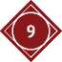**IMPORTANT NOTE:** Battle formations is similar to groups of monsters. New monsters are created by the Judge, and the notes given here are just guidelines. There will not be provided detailed examples. In Domains of War - Battles, on page 81 and onwards, detailed conversion rules are provided to create units to be used in large scale battles. The ideas and practical application are the same and many of the same principles may be used if you, the judge, are in doubt or need inspiration. The whole idea is that the cohort is a ready and simple to use challenge. Everything required should be incorporated into the monster statistics.

Irregular

Irregular formations are poorly-trained and undisciplined bands or hordes. They are incapable of any advanced tactics and must rely on individual ferocity or sheer mass. Examples include beastmen, mindless undead, poorly-trained and undisciplined cavalry, peasants with spears, riders of particularly aggressive, unpredictable, or vicious mounts, and packs of war beasts or trained monsters (whether they carry riders or not). Irregulars are tightly packed. There should be at least 6 human sized creatures or 3 cavalry sided creatures in a cohort.

**Qualities:**

» Gains +1 AC, +1 saves, and +2 to attack throws.

» Makes two attacks, or one if half or more are killed.

» Takes triple damage from all area attacks that affect entire cohort; and if there is a save, it auto fails.

» If leader falls, they flee automatically. Cannot be ordered to retreat or to delay their action.

Loose

Loose formations are well-trained soldiers or cavalry fighting in open order. Their extended formation allows them to easily pass through or around obstacles or friendly cohorts, and to withdraw in the face of enemy missiles or heavy troops. Examples are battle wagons with wizards inside, chariots, rangers, NPC adventurer groups etc. In a loose formation there are 4 human sized or 2 cavalry sized in a cohort.

**Qualities:**

» Gains +1 AC, +2 saves, and +2 to attack throws.

» Can do a defensive retreat without declaring (as if it had Skirmish proficiency).

» Makes one attack per two creatures and one ranged attack for each creature in the cohort.

» Takes damage x2 from all area attacks that affect entire cohort.

» The damage is evenly distributed on all in the cohort.

Formed

Formed formations are highly-disciplined soldiers fighting shoulder-to-shoulder in close order. Formed soldiers are sturdy defenders, usually heavily armed and armored. They are used to take or hold ground in close combat. Formed Mounted are generally shock troops equipped with lances. In a formed formation, there are 6 human sized and 3 cavalry sized in one cohort.

**Qualities:**

» Gains +2 AC, +1 saves, and +2 to attack throws.

» Makes one attack per two creatures in the Cohort.

» Take damage x2 from all area attacks that affect entire Cohort, and if there is a save it auto fails.

» Missile weapons can do area damage. Target must save vs. Blast. Full damage on a success, half on a failure.

» **Defensive Stance:** If equipped with shields and not mounted, Cohort AC is increased by +2. Without shields it gain +1 AC. In addition it receives a +2 bonus on morale rolls. Spears can be set, and other special stances are applied. Can be done by a cohort that either delayed their action or marched, and is not threatened by any enemy.

» The damage is evenly distributed on all in the cohort.

Flyer

Flyers are aerial monsters or cavalry. Flyers generally fly wingtip- to-wingtip in order to maximize striking power. Some flyers carry riders equipped with lances or bows, other flyers rely on beak and talon. Fantasy examples include dragon riders, giant eagles, griffin knights, and wyverns. There are only one horse sized flyer in a cohort, and there are no qualities added. Just the rider(s) and the mount added.

War Machinery

War Machinery includes all crew-served pieces of artillery and siege equipment. War Machinery crews are only lightly equipped with hand weapons or no weapon at all, with the real value being the machine itself. There are only one war machine in a Cohort. If the machine requires a large crew, the crew is added with additional irregular crew cohorts. War machinery always includes at least one person with siege engineering and he becomes the leader.

**Qualities:**

» If someone deals damage in one blow more than the hit point value of an individual participant, he can cleave.

» Fails the save and take damage x3 from magic burst attacks.

THE cLEAvE vALuE

If someone deals damage in one blow more than the hit point value of an individual participant, he can cleave. The hit pint value required to kill one participant is called the cleave value. The cleave value should be noted on the cohort. It is the rolled Hit Dice average on participating creatures groups.

**THE iN-GAME BENEFiT**

The idea with battle formations and cohorts is that it is an easy and ready to use monster in combat. Use the characteristic provided or create your own version. In combat it is time efficient. In addition, it makes individual soldiers more dangerous. It makes sense that soldiers are dangerous encounters even for professional adventures.

USiNG COHORTS iN COMBAT -

**CHALLENGES**

During a game session, the cohort is used just like any other monster. The cohort plays just like a swarm monster, though it requires an attack throw to hit and it has a defined number of attacks. There are no special rules when using such cohorts, however there may arise some challenges that could inspire doubt for the judge. These situations are discussed below.

Targeting Individuals Inside The Cohort

Other cohorts may never target individuals. Targeting a specific individual or member of a cohort imposes -2 penalty to hit with ranged attacks. In melee, if the attacker is adjacent, it can be done with no penalties.

Creatures Hiding Inside The Cohort

Heroes, or other allies, may stand inside the cohort if there is room. They become a member of the cohort and targeting them follows the rules for targeting individuals inside a cohort (see above).

Leading A Cohort

Heroes or other creatures may be assigned as leaders to a cohort. It requires no action to lead and instruct a cohort organized as a unit. A unit of 120 heavy infantry, consists of 24 - 6 men cohorts, and one leader controls it and it rolls one initiative. The leader can hide inside one of the cohort, but it must be one of those in the front or else the unit takes a morale penalty.

Spell Blast Areas

A damage spell must cover at least half the cohort or more, or else the damage of the spell is halved.

NEW MONSTERS

iRREGULAR COHORTS

AXEMEN (iRREGULAR)

AC 3, HD 6, hp 24, #AT 2 x great axe (1d10) or 2 x throwing axe (1d6), hit: 8+, MV 120’ (40’), SV PP13 PD12 BB14 SW14 S15 (F1), ML -1, AL N, XP78.

» **Equipment:** Great axe, two throwing (hand) axes, leather armor.

» **Cohort:** Occupies a 15’ x 15’ area, but may expand or shrink as condition merit. Consists of 6x barbarians.

» **Area Attacks:** fails save and damage x3.

» **Cleave Value:** 4+. Cannot be ordered to a defensive retreat or delay their action on the order of initiative.

» **Berserk:** Gain a +2 bonus to attack throws and becomes immune to fear. However, the character has a -2 penalty to AC and cannot retreat from combat. Once it has begun, a berserker rage cannot be ended until combat ends.

HUNTERS (iRREGULAR)

AC 4, HD 6, hp 24, #AT 2 x hand axe (1d6) or 2 x javelins (1d6), hit: 8+, MV 120’ (40’), SV PP13 PD12 BB14 SW14 S15 (F1), ML- 1, AL N, XP78.

» **Equipment:** 6 javelins, hand axe, shield, leather armor

» **Cohort:** Occupies a 15’ x 15’ area, but may expand or shrink as condition merit. Consists of 6x hunters.

» **Area Attacks:** fails save and damage x3.

» **Cleave Value:** 4+. Cannot be ordered to a defensive retreat or delay their action on the order of initiative.

MOUNTED MiLiTiA (iRREGULAR)

AC 6, HD 9, hp 36, #AT 2 x spear (1d6+1) or 2 x javelin (1d6) or and 2 x hoofs (1d6), hit: 7+, MV 60' (20’)/180' (60’) mounted, SV PP14 PD13 BB15 SW15 S16 (F1), ML 0, AL N, XP120.

» **Equipment:** spear, 2 javelins, shield, leather armor.

» **Mounted Charge:** +2 to hit, but -2 to AC.

» **Cohort:** Occupies a 15’ x 15’ area, but may expand or shrink as  
condition merit. Consists of 3x mounted brigands. See above.

» **Area Attacks:** fails save and damage x3.

» **Cleave Value:** 4+ (rider). Cannot be ordered to a defensive retreat or delay their action on the order of initiative.

WAR-DoGs (IRREGULAR)

AC 6, HD 11+10, hp 54, #AT 2 x bite (1d6+1), hit: 6+, MV 90’ (30’), SV PP13 PD12 BB14 SW14 S15 (F1), ML +1, AL N, XP248.

» **Equipment:** Whip, sword, leather armor.

» **Cohort:** Occupies a 15’ x 15’ area, but may expand or shrink as condition merit. Consists of 5x war-dogs with spiked collar and one animal trainer.

» **Area Attacks:** fails save and damage x3.

» **Cleave Value:** 9+. Cannot be ordered to a defensive retreat or delay their action on the order of initiative. When the animal trainer dies, the dogs flee.

LoosE coHoRTs

ADVENTURERs (LoosE)

AC 6, HD 4, hp 16, #AT 2 x sword (1d6) or 4 x crossbow (1d6), hit: 7+, MV 90' (30’), SV PP13 PD12 BB14 SW14 S15 (F1), ML 0, AL N, XP52.

» **Equipment:** Chainmail and shield. Crossbows and swords.

» **Cohort:** Occupies a 15’ x 15’ area, but may expand or shrink as condition merit. Consists of two fighters, a thief and a cleric, all level 1. Area attacks deals damage x2.

» **Cleave Value:** 4+. Can do a defensive retreat without declaring. Can do one melee attack and two missile attack if engaged only in one side.

HoRsE ARcHERs (LoosE)

AC 4, HD 8, hp 34, #AT 2 x sword (1d6+1) or 2 x bow (1d6) or 2 x hoofs (1d4), hit: 7+, MV 60' (20’) / 240' (80’) mounted, SV PP13 PD12 BB14 SW14 S15 (F1), ML +1, AL C, XP156.

» **Equipment:** Ring-mail, sword, composite bow, warhorse.

» **Mounted Charge:** +2 to hit, but -2 to AC.

» **Cohort:** Occupies a 15’ x 15’ area, but may expand or shrink as condition merit. Consists of 2x mounted archers. Area attacks deals damage x2.

» **Cleave Value:** 4+ (rider). Can do a defensive retreat without declaring.

RANGERs (LoosE)

AC 3, HD 4, hp 16, Att 2 x hand axe (1d6) or 4 x shortbow (1d6), hit: 8+, MV 120' (40’), SV PP13 PD12 BB14 SW14 S15 (F1), ML 0, AL N, XP52.

» **Equipment:** Shortbow, hand axe, leather armor, shield.

» **Cohort:** Occupies a 15’ x 15’ area, but may expand or shrink as condition merit. Consists of 4x rangers. Area attacks deals damage x2

» **Cleave Value:** 4+. Can do a defensive retreat without declaring. Can do one melee attack and two missile attack if engaged only in one side.

sLINGER sKIRMIsHERs (LoosE)

AC 3, HD 4, hp 16, #AT 2 x short sword (1d6) or 4 x sling (1d4), hit: 8+, MV 120' (40’), SV PP13 PD12 BB14 SW14 S15 (F1), ML 0, AL N, XP52.

» **Equipment:** Sling, short sword, leather armor, shield.

» **Cohort:** Occupies a 15’ x 15’ area, but may expand or shrink as condition merit. Consists of 4x slingers. Area attacks deals damage x2.

» **Cleave Value:** 4+. Can do a defensive retreat without declaring. Can do one melee attack and two missile attack if engaged only in one side.

FoRMED coHoRTs

ARcHERs (FoRMED)

AC 4, HD 6, hp 24, #AT 3 x sword (1d6) or 3 x Composite bow (1d6), hit: 8+, or ranged burst 15x15 area save vs. blast (1d6 or half), MV 120’ (40’), SV PP14 PD13 BB15 SW15 S16 (F1), ML +1, AL N, XP78.

» **Equipment:** Leather armor, sword, composite bow.

» **Cohort:** Occupies a 15’ x 15’ area, but may expand or shrink as condition merit. Consists of 6x archers.

» **Area Attacks:** fails save and damage x2.

» **Cleave Value:** 4+.

» **Defensive Stance:** AC is increased by +1 and +2 moral.

sPEAR INFANTRY (FoRMED)

AC 8, HD 6, hp 24, #AT 3 x spear (1d6), hit: 8+, MV 90’ (30’), SV PP14 PD13 BB15 SW15 S16 (F1), ML +1, AL N, XP78.

» **Equipment:** Lamellar armor, shield, sword, spear.

» **Cohort:** Occupies a 15’ x 15’ area, but may expand or shrink as condition merit. Consists of 6x spear men.

» **Area Attacks:** fails save and damage x2.

» **Cleave Value:** 4+.

» **Defensive Stance:** AC is increased by +2 and +2 moral. When defensive and spears set, acts on chargers initiative. Spears does 2d6 instead of 1d6 in damage against charging enemies.

sWoRD INFANTRY (FoRMED)

AC 8, HD 6, hp 24, #AT 3 x sword (1d6) or 3 x javelin (1d6), hit: 8+, or ranged burst 15x15 area save vs. blast (1d6 or half), MV 90’ (30’), SV PP14 PD13 BB15 SW15 S16 (F1), ML +1, AL N, XP78.

» **Equipment:** Chainmail, shield, sword, 2 javelins.

» **Cohort:** Occupies a 15’ x 15’ area, but may expand or shrink as condition merit. Consists of 6x swordsmen.

» **Area Attacks:** fails save and damage x2.

» **Cleave Value:** 4+.

» **Defensive Stance:** AC is increased by +2 and +2 moral.

VETERAN cRossBoW INFANTRY

(FoRMED)

AC 7, HD 18, hp 84, Att 3 x sword (1d6+2) or 3 x crossbow (1d6), hit: 6+, or ranged burst 15x15 area save vs. blast (1d6 or half), MV 90’ (30’), SV PP13 PD12 BB14 SW14 S15 (F3), ML +2, AL N, XP390.

» **Equipment:** Chainmail, sword and dagger, crossbow, pavise.

» **Cohort:** Occupies a 15’ x 15’ area, but may expand or shrink as condition merit. Consists of 6x crossbowmen.

» **Area Attacks:** fails save and damage x2.

» **Cleave Value:** 12+.

» **Defensive Stance:** AC is increased by + 1 and +2 moral.

» **Pavise Shield:** If stationary, they can mount a pavise shield. A shield with spikes to set in the ground. This increase their AC by +1 against missile attacks. And in defensive stance, their AC increases by +2 instead of+1. While moving the shield is carriec on the back and no benefit is gained.

PHALANX (FoRMED)

AC 8, HD 12, hp 48, #AT 3 x pike (1d10) and 3 x swords (1d6), hit: 7+, MV 90’ (30’), SV PP13 PD12 BB14 SW14 S15 (F2), ML +1, AL N, XP174.

» **Equipment:** Lamellar armor, shield, sword, polearm (pike).

» **Cohort:** Occupies a 15’ x 15’ area, but may expand or shrink as condition merit. Consists of 3x men with shields and swords and behind them 3x men with pikes.

» **Area Attacks:** fails save and damage x2.

» **Cleave Value:** 8+.

» **Defensive Stance:** AC is increased by +2 and +2 moral. When defensive and pikes set, acts on chargers initiative. Pikes does 2d10 instead of 1d10 in damage against charging enemies.

» **Phalanx Formation:** Pikes may strike enemies in front of the men with shields and swords, and gain 6x attacks. However, the unit has a facing - forwards and this is the only direction the unit may make attacks. Enemies attacking its flank, gain +2 to hit sides and +4 to hit rear. The unit may end the phalanx formation, but then only get 3x attacks.

cAVALRY (FoRMED)

AC 8, HD 12, hp 48, #AT 3 x flail (1d6+1) or 3 x lance (1d10+1) or 2 x hoofs (1d6), hit: 7+, MV 90' (30’) / 180' (60’) mounted, SV PP13 PD12 BB14 SW14 S15 (F1), ML +2, AL N, XP339.

» **Equipment:** Lamellar armor, shield, lance, flail, warhorse.

» **Mounted Charge:** +2 to hit, but -2 to AC. Damage with lance is 2d10+1 instead of 1d10+1. Overrun special maneuver is with -2 penalty to hit.

» **Cohort:** Occupies a 15’ x 15’ area, but may expand or shrink as condition merit. Consists of 3x mounted lancers.

» **Area Attacks:** fails save and damage x2.

» **Cleave Value:** 4+ (rider).

» **Defensive Stance:** Unit AC is increased by +1 and +2 moral.

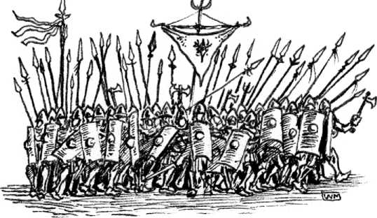

cHARiOT (FORMED)

AC 6, HD 6, hp 24, #AT 1 x spear (1d8+1) and 1 x hoofs (1d4) or 1 x shortbow (1d6) and 1 x hoofs (1d4) or 2 x hoofs (1d4), hit: 7+, MV 90' (30’) / 240' (80’) chariot, SV PP13 PD12 BB14 SW14 S15 (F1), ML +2, AL N, XP84.

» **Equipment:** Ring-mail, spear, composite bow, chariot.

» **Mounted Charge:** +2 damage, but -2 to hit.

» **Cohort:** Overrun special maneuver is with -2 penalty to hit. Occupies a 15’ x 15’ area, but may expand or shrink as condition merit. Consists of a chariot pulled by two light warhorses, with one archer or lancer and one driver.

» **Area Attacks:** fails save and damage x2.

» **Cleave Value:** 4+ (crew).

» **Defensive Stance:** Unit AC is increased by +1 and +2 moral.

wAR-MAcHiNEs

HEAVY BALLisTA (wAR-MAcHiNE)

AC 4, HD 4, hp 16, #AT 1/5 x ballista (3d6) or 2 x dagger (1d4), Hit: 8+, MV stationary, SV PP15 PD14 BB16 SW16 S17 (F1), ML +1, AL N, XP64

A heavy ballista (SHP 2) operated by four men, one of them with the siege engineer proficiency. Range 300’. Can damage creatures and all structures. Targets a 15’ line or 5’ radius. All in target save vs. blast.

» **Cohort:** Occupies a 15’ x 15’ area, but may expand or shrink as condition merit.

» **Area Attacks:** fails save and damage x3.

» **Cleave Value:** 4+ (crew).

MAGiciAN BATTLEwAGON (wAR-MAcHiNE)

AC 7, HD 8+6, hp 38, #AT 1 x Sword (1d6) and 1 x hoofs (1d8) or 1 x crossbow (1d6) and 1 x hoofs (1d8) or 2 x hoofs (1d8), hit: 8+, and spell. MV 120’ (40’), SV PP13 PD13 BB15 SW11 S12 (M3), ML +1, AL Any, XP 226.

A magician (not included) in a reinforced and enclosed four wheeled wooden wagon with arrow slits (SHP 3), pulled by two war-horses, driven by a wagoner and defended by one soldier. Overrun special maneuver is with -2 penalty to hit.

» **Cohort:** Occupies a 15’ x 15’ area, but may expand or shrink as condition merit.

» **Area Attacks:** fails save and damage x3.

» **Cleave Value:** 4+ (crew).

MAGiciAN (iNsiDE THE wAGON)

Mage 3; Int 13; AC 10, HD 3*, hp 11, #AT 1 x dagger (1d4) or spell, Hit: 10+, MV 120’ (40’), SV PP13 PD13 BB15 SW11 S12 (M3), ML +1, AL Any, XP65;

» **Proficiencies:** Elementalism, Alchemy, Healing;

» **Spells:** 2x 1st, 1x 2nd; **Repertoire:** 1st - *burning hands*, *darkness*, *magic missile*, 2nd - *deathless minion*

wAGON MOUNTED BALLisTA (wAR-MAcHiNE)

AC 4, HD 7, hp 28, #AT 2 x repeating ballista (1d10) and 1 x hoofs (1d6) or 3 x hoofs (1d6), Hit: 8+, MV 90' (30’), SV PP15 PD14 BB16 SW16 S17 (F1), ML +1, AL N, XP124

A repeating ballista mounted on an open four wheeled wooden wagon, pulled by two war-horses, driven by a wagoner and operated by two men with the siege engineer proficiency. Range 200’. Can damage creatures and not structures.

» **Cohort:** Occupies a 15’ x 15’ area, but may expand or shrink as condition merit.

» **Area Attacks:** fails save and damage x3.

» **Cleave Value:** 4+ (crew). Overrun special maneuver is with -2 penalty to hit.

» **Note:** Can fire its repeating ballista with a -4 penalty to hit and at the same time move and attack with its hoofs.

» **Magazine:** Holds 20 bolts. A malfunction occurs whenever the crew’s attack throw is an unmodified 1. A malfunction takes 1 turn for a siege engineer to repair, during which time the ballista cannot be fired

FLYERs

ELVEN PEGAsUs cAVALRY (FLYER)

AC 6, HD 3+2, hp 15, #AT 1 x javelin (1d6+1) or 1 x composite bow (1d6+2) or 2 x hoofs (1d6), hit: 6+, MV 120' (40’) / 240’ (80’) / 480’ (160’) flying, SV PP12 PD12 BB14 SW14 S14 (ES1), ML +1, AL N, XP71.

Consists of 1x elven warriors and 1x pegasus.

» **Equipment:** Composite bow, javelins, shield, scale mail.

» **Mounted Charge:** +2 damage, but -2 to hit.

» **Cohort:** Occupies a 15’ x 15’ area, but may expand or shrink as condition merit.

» **Cleave Value:** 4+ (rider).



**opEN GAME LicENsE**

DESIGNATION OF PRODUCT IDENTITY

The names Autarch™, Adventurer Conqueror King™, Adventurer Conqueror King System™, ***ACKS***™, and Auran Empire™, when used in any context, are product identity. The title Ruins of Cyfandir™ is Product Identity. All artwork, logos, maps, presentation, NPCs, locations, and geography are product identity.

DESIGNATION OF OPEN GAME CONTENT

All game mechanics and rules are open game content, with the exception of text and terms defined above as product identity.

OPEN GAME LICENSE Version 1.0a

The following text is the property of Wizards of the Coast, Inc. and is Copyright 2000 Wizards of the Coast, Inc. (“Wizards”). All Rights

Reserved.

1. Definitions: (a)”Contributors” means the copyright and/or trademark owners who have contributed Open Game Content; (b)”Derivative Material” means copyrighted material including derivative works and translations (including into other computer languages), potation, modification, correction, addition, extension, upgrade, improvement, compilation, abridgment or other form in which an existing work may be recast, transformed or adapted; (c) “Distribute” means to reproduce, license, rent, lease, sell, broadcast, publicly display, transmit or otherwise distribute; (d)”Open Game Content” means the game mechanic and includes the methods, procedures, processes and routines to the extent such content does not embody the Product Identity and is an enhancement over the prior art and any additional content clearly identified as Open Game Content by the Contributor, and means any work covered by this License, including translations and derivative works under copyright law, but specifically excludes Product Identity. (e) “Product Identity” means product and product line names, logos and identifying marks including trade dress; artifacts; creatures characters; stories, storylines, plots, thematic elements, dialogue, incidents, language, artwork, symbols, designs, depictions, likenesses, formats, poses, concepts, themes and graphic, photographic and other visual or audio representations; names and descriptions of characters, spells, enchantments, personalities, teams, personas, likenesses and special abilities; places, locations, environments, creatures, equipment, magical or supernatural abilities or effects, logos, symbols, or graphic designs; and any other trademark or registered trademark clearly identified as Product identity by the owner of the Product Identity, and which specifically excludes the Open Game Content; (f) “Trademark” means the logos, names, mark, sign, motto, designs that are used by a Contributor to identify itself or its products or the associated products contributed to the Open Game License by the Contributor (g) “Use”, “Used” or “Using” means to use, Distribute, copy, edit, format, modify, translate and otherwise create Derivative Material of Open Game Content. (h) “You” or “Your” means the licensee in terms of this agreement.

2. The License: This License applies to any Open Game Content that contains a notice indicating that the Open Game Content may only be Used under and in terms of this License. You must affix such a notice to any Open Game Content that you Use. No terms may be added to or subtracted from this License except as described by the License itself. No other terms or conditions may be applied to any Open Game Content distributed using this License.

3.Offer and Acceptance: By Using the Open Game Content You indicate Your acceptance of the terms of this License.

1. . Grant and Consideration: In consideration for agreeing to use this License, the Contributors grant You a perpetual, worldwide, royalty free, non-exclusive license with the exact terms of this License to Use, the Open Game Content.
2. .Representation of Authority to Contribute: If You are contributing original material as Open Game Content, You represent that Your Contributions are Your original creation and/or You have sufficient rights to grant the rights conveyed by this License.
3. .Notice of License Copyright: You must update the COPYRIGHT NOTICE portion of this License to include the exact text of the COPYRIGHT NOTICE of any Open Game Content You are copying, modifying or distributing, and You must add the title, the copyright date, and the copyright holder’s name to the COPYRIGHT NOTICE of any original Open Game Content you Distribute.
4. . Use of Product Identity: You agree not to Use any Product Identity, including as an indication as to compatibility, except as expressly licensed in another, independent Agreement with the owner of each element of that Product Identity. You agree not to indicate compatibility or co-adaptability with any Trademark or Registered Trademark in conjunction with a work containing Open Game Content except as expressly licensed in another, independent Agreement with the owner of such Trademark or Registered Trademark. The use of any Product Identity in Open Game Content does not constitute a challenge to the ownership of that Product Identity. The owner of any Product Identity used in Open Game Content shall retain all rights, title and interest in and to that Product Identity.
5. . Identification: If you distribute Open Game Content You must clearly indicate which portions of the work that you are distributing are Open Game Content.
6. . Updating the License: Wizards or its designated Agents may publish updated versions of this License. You may use any authorized version of this License to copy, modify and distribute any Open Game Content originally distributed under any version of this License.
7. Copy of this License: You MUST include a copy of this License with every copy of the Open Game Content You Distribute.
8. . Use of Contributor Credits: You may not market or advertise the Open Game Content using the name of any Contributor unless You have written permission from the Contributor to do so.
9. Inability to Comply: If it is impossible for You to comply with any of the terms of this License with respect to some or all of the Open Game Content due to statute, judicial order, or governmental regulation then You may not Use any Open Game Material so affected.
10. Termination: This License will terminate automatically if You fail to comply with all terms herein and fail to cure such breach within 30 days of becoming aware of the breach. All sublicenses shall survive the termination of this License.
11. Reformation: If any provision of this License is held to be unenforceable, such provision shall be reformed only to the extent necessary to make it enforceable.
12. COPYRIGHT NOTICE

Open Game License v 1.0 Copyright 2000, Wizards of the Coast, Inc.

System Reference Document Copyright 2000, Wizards of the Coast, Inc.; Authors Jonathon Tweet, Monte Cook, Skip Williams, based on original material by E. Gary Gygax and Dave Arneson.

System Reference Document Copyright 2000-2003, Wizards of the Coast, Inc.; Authors Jonathan Tweet, Monte Cook, Skip Williams, Rich Baker, Andy Collins, David Noonan, Rich Redman, Bruce R. Cordell, John D. Rateliff, Thomas Reid, James Wyatt, based on original material by E. Gary Gygax and Dave Arneson.

Modern System Reference Document Copyright 2002-2004, Wizards of the Coast, Inc.; Authors Bill Slavicsek, Jeff Grubb, Rich Redman, Charles Ryan, Eric Cagle, David Noonan, Stan!, Christopher Perkins, Rodney Thompson, and JD Wiker, based on material by Jonathan Tweet, Monte Cook, Skip Williams, Richard Baker, Peter Adkison, Bruce R. Cordell, John Tynes, Andy Collins, and JD Wiker.

Adventurer Conqueror King Copyright 2011, Autarch™ LLC; Authors Alexander Macris, Tavis Allison, Greg Tito, and Ryan Browning.

Basic Fantasy Role-Playing Game Copyright 2006-2008, Chris Gonnerman.

Castles & Crusades: Players Handbook Copyright 2004, Troll Lord Games; Authors Davis Chenault and Mac Golden.

Castles & Crusades: Monsters Product Support Copyright 2005, Troll Lord Games.

Creature Compendium, Copyright 2015 New Big Dragon; Richard J. LeBlanc, Jr., “Animal Mummy,” “Flailing Spirit,” “Sarcophagal Worm.”

Labyrinth Lord ™ Copyright 2007-2009, Daniel Proctor; Author Daniel Proctor.

Labyrinth Lord™ Advanced Edition Companion Copyright 2010, Daniel Proctor; Author Daniel Proctor.

Swords & Wizardry™ Monstrosities, Copyright 2012 Frog God Games; Matthew J. Finch, “Jackal of Darkness,” “Tunnel Prawn;” Scotty Wylie Roberts, Myrystyr, “Fungal Creeper”.

END OF LICENSE

Copyright 2012-2014 Autarch LLC. Autarch™, Adventurer Conqueror King™, Adventurer Conqueror King System™, and ***ACKS***™ are trademarks of Autarch Auran Empire™ is a trademark of Alexander Macris.

